**Date:**

**Staying On Agreement**

|  |
| --- |
| **Explain what a Staying On Agreement is and why it is important**   * A written agreement the young person and carer family develop together to outline the expectations of living together * Everyone has different expectations of living together so it is important to be clear about what is expected of each other and how you overcome issues if they arise   **Use the ‘Setting Up a Staying On Agreement Discussion Guide’ to fill out this agreement**  **Once completed, attach the agreement to the Staying On Subsidy Application Form** |
| What is working well? |
| Discuss what is going well in the current arrangement, this can be done separately or as a group using the Discussion Guide for different topic areas. |
|  |
| What are the things that we would like to discuss? |
| Discuss what is important to the young person and carer family in the living arrangement and what could become an issue. You can use the Discussion Guide to come up with a list of topics to discuss. Write down the key issues for discussion that came up. |
| **Young Person**    **Caregiver** |
| What are our plans to make it work? |
| Discuss each topic area that came up and what are your plans are to make it work. This may include a list of who is responsible for what or going through each topic area. Note here the non-negotiables, key house rules and expectations. |
| **Young Person**    **Caregiver** |
| Finances - What is the Staying On Subsidy going to be used for? |
| How is the young person going to contribute? List what the subsidy is going to pay for and how the money is going to be distributed. |
| **What happens if we disagree or need to change this?** |
| What is the housing pathway plan? How is Staying On in this arrangement going to help to achieve that? |
| Discuss how long the arrangement is for and what happens if the young person wants to end the arrangement. |
|  |
| What do we do if we have any issues? |
| Discuss what each party is going to do: if they are not happy with the agreement; someone is not meeting their side of the agreement; and if there are any issues. This may need a discussion with other household members. |
|  |
| How do we end the agreement? |
| List what the young person and carer or family members agree to should one person want to end the agreement; include how much notice is needed. |
|  |

**Carer/s and Family**

**Roles & Responsibilities**

* Support and encourage the young person with their transition to independence,   
  including contribution to costs
* Discuss any issues or concerns with the young person
* Review the agreement with the young person if it needs to be amended
* Contact Home Stretch WA to discuss any living arrangement issues or concerns
* Participate in living arrangement reviews with Home Stretch WA
* Notify Home Stretch WA as soon as the young person leaves the living arrangement,   
  to avoid liability for overpayment

**Young Person**

* Meet with the Home Stretch WA Transition Coach as agreed, to work towards   
  a housing pathway plan, agreed goals and transition to independence
* Contribute to costs of the living arrangement once an income is received
* Discuss any living arrangement issues or concerns with the with the carer/s or family
* Contact Home Stretch WA to discuss any living arrangement issues or concerns
* Participate in living arrangement reviews with Home Stretch WA
* Notify Home Stretch WA if you are no longer in the living arrangement

**Home Stretch WA Transition Coach**

* Support the young person to explore their goals and aspirations, develop a housing pathway plan and assist with transition to independence
* Support the young person to develop the Staying On Agreement
* Be available to support the young person with the living arrangement

**Home Stretch WA Staying On Facilitator**

* Support the carer/s and family to develop the Staying On Agreement
* Support the carer/s and family with the living arrangement including access to resources and specialised supports
* Facilitate and organise reviews of the Staying On Agreement and Subsidy as required

**Department of Communities**

* Payment of the Staying On Subsidy through the Department of Communities Subsidy Processing Unit

We (young adult’s name) and (carer/s or family member) agree to continue the ‘Staying On Agreement’.

**Agreement**

* We understand the living arrangement is voluntary and until the young adult turns 21
* We agree to respect each other and follow any agreed ‘house rules’
* We are going to review the Staying On Agreement should things change and if any   
  areas need to be amended
* The Staying On Agreement is going to be reviewed on (4 weeks from agreement date), then reviewed every 3 months or as agreed
* We agree to an annual review of the Staying On Agreement
* We agree to give the each other weeks' notice to end the Staying On Agreement
* We agree to contact Home Stretch WA if this agreement is not working and/or the young person moves out of the living arrangement

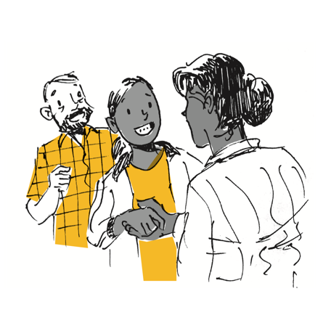

|  |  |
| --- | --- |
| Young Adult & Carer/s Signatures | Date |
| Name:  Signature: |  |
| Name:  Signature: |  |
| Name:  Signature: |  |

|  |  |  |
| --- | --- | --- |
| Actions for follow up | Who | Date |
|  |  |  |
|  |  |  |
|  |  |  |
|  |  |  |